Parallel and Distributed Systems: Assignment #4.
Date: 10/02/2019
Authors: Artem Reshetnikov (Index No.)
Lawrence Adu-Gyamfi (1484610)

Question 1.

List of products purchased in Stockholm

Answer

val transacs = sc.textFile("spark2/transactions.csv").map(line => line.split(","))

val prodStock = transacs.filter(tr => tr(6).toString == "Stockholm")

val prodList = prodStock.map(tr => (tr(2).toInt, tr(6).toString))

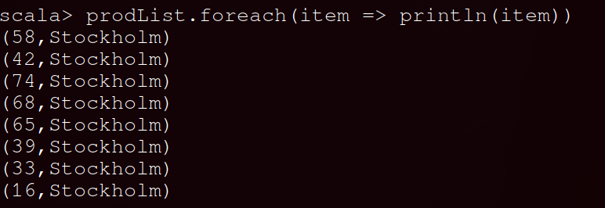

Question 2

Sort the transactions by quantity and get the product id with the largest quantity in a transaction

Answer

val l_quant = transacs.map(tr => (tr(2).toInt, tr(4).toInt))

val quant = l_quant.reduceByKey((a,b) => a+b)

val sorted_quant = quant.sortBy(_._2)

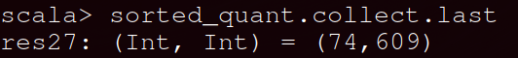

Question 3

How many products in total and how many different products we have in the input dataset?

(a) Different products

sorted_quant.countByKey().values.sum

(b) Total Products

sorted_quant.values.sum

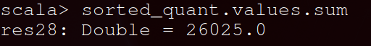

Question 4

How many customers have a transaction with a product price between 80 and 100?

Answer (80<x<100)

val custPrice_1 = transacs.filter (tr => (tr(5).toInt >80 && tr(5).toInt < 100 ))

val custPrice = custPrice_1.map(tr => (tr(1).toInt, tr(5).toInt))

val custPrice2 = custPrice.sortBy(_._2)

custPrice2.keys.distinct.count()

Question 5

Provide a list of cities with the maximum value of products purchased in a transaction. Then sort them by quantity of products and provide the city with the largest quantity

Answer

val city = transacs.map(tr => (tr(6).toString, tr(4).toInt))

val city_max = city.reduceByKey(math.max(_, _))

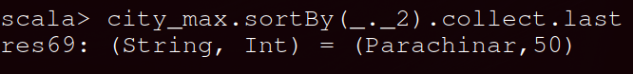
val sorted = city_max.sortBy(_._2)
val max = sorted.collect.last._2
val max_city = sorted.filter(tr => tr._2 == max)

Question 6

Using the providers.csv dataset, find the names of the providers of the list of cities of question 5

Question 7

Using combineByKey transformations, calculate :

(a) average price of products purchased by each customer

val transdata = sc.textFile("transactions.csv").map(line => line.split(","))

def createCombiner = (t: (Int, Int)) => (t._2.toInt, 1)

def mergeValue = (price: (Int, Int), item: (Int, Int)) => (price._1 + item._2, price._2 + 1)

def mergeCombiner = (price_1: (Int, Int), price_2: (Int, Int)) => (price_1._1 + price_2._1, price_1._2 + price_2._2)

val combined = transdata.map( t => (t(1).toInt, (t(2).toInt, t(5).toInt))).combineByKey(createCombiner, mergeValue, mergeCombiner).map(r => (r._1, r._2._1/r._2._2))

(b) Maximum price of products purchased by each customer

def createCombiner = (t: (Int, Int)) => (t._2.toInt)

def mergeValue = (price: (Int), item: (Int, Int)) => math.max(price, item._2)

def mergeCombiner = (price_1: (Int), price_2: (Int)) => math.max(price_1, price_2)

val combined = transdata.map( t => (t(1).toInt, (t(2).toInt, t(5).toInt))).combineByKey(createCombiner, mergeValue, mergeCombiner).map(r => (r._1, r._2))

(c) Total amount of products purchased by each customer

def createCombiner = (t: (Int, Int)) => (t._2.toInt)

def mergeValue = (quantity: (Int), item: (Int, Int)) => (quantity + item._2)

def mergeCombiner = (quantity_1: (Int), quantity_2: (Int)) => (quantity_1+ quantity_2)

val combined = transdata.map( t => (t(1).toInt, (t(2).toInt, t(4).toInt))).combineByKey(createCombiner, mergeValue, mergeCombiner).map(r => (r._1, r._2))

